**Intrusion Detection System**

A project report submitted by

Ismail Hossain

ID#18203030

Hasan Ahmed

ID#18203044

Ifrat Jahan Lima

ID#18203083

In partial fulfillment of the requirements for the course project of

Course Name: Fundamental of Electronics and Digital System Lab

Course Code: CSC 232



Department of Computer Science and Engineering

IUBAT- International University of Business Agriculture and Technology

**Intrusion Detection System**

A Project Report of

Fundamentals of Electronics and Digital System

Lab

Course Code: CSC 232

**Submitted to**

**Dr. Md. Hasibur Rashid Chayon**

Associate Professor

Department of Computer Science & Engineering

IUBAT-International University of Business Agriculture and Technology

# **Abstract**

Nowadays security is one of our main concerns. Intrusion security system is one of the popular security system of this time. Intrusion detection system is a security system which we can set for a locked room or gate containing something valuable. This project introduces a smaller but smarter security system with alarm. We want to introduce a security system which gives alarm if someone or something wants to break through the system. Intrusion security system can be made of many kinds. Our project is based on a circuit containing laser security and an alarm system. By using a medium complicated circuit, we managed to build a laser light sensor security and an alarm. If the laser light is obstructed by something, then the alarm will be turned on automatically. After building the project circuit we tested it for several time and it worked perfectly as we assumed. If anything obstructs the pathway of light to laser light sensor, the alarm turns on. Using this project, we can assure the proper security of a closed door or a home security. By minimizing the use of various components and complicated circuits we want it to be used in small houses and other security stores very easily and comfortably.

**Table of Contents**

**Abstract** ii

**Chapter 1 Introduction**

1.1 Background: 7

1.2 Scope of Study: 8

1.3 Objective: 8

1.4 Chapter Summary: 9

**Chapter 2 Theoritical Background**

2.1 Components Used in The Project: 11

2.2 Components Materials Expenditures: 17

**Chapter 3 Project Development**

3.1 Circuit Diagram: 19

3.2 Circuit Setup: 20

3.3 Project Setup: 21

3.4 Working Procedures of the Project: 22

3.5 Experiments: 23

**Chapter 4 Experiment Result & Discussion**

4.1 Experiment results 25

4.2 Discussion: 26

**Chapter 5 Conclusion**

5.1 Conclusion 28

5.2 Importance of the Project: 29

5.3 Achievement: 29

5.4 Limitations: 30

5.5 Future Scopes: 30

**References** 32

**Table of Figure**

**Figure2. 1:** A Bread Board 10

**Figure2. 2:** A 9V Battery with Connective Wires 11

**Figure2. 3:** A BC547 NPN Transistor 12

**Figure2. 4:** A LDR with Symbol 12

**Figure2. 5:** A LED with Symbol 13

**Figure2. 6:** A resistor with Symbol 14

**Figure2. 7:** A Buzzer 14

**Figure2. 8:** A Laser Light Pointer 15

**Figure2. 9:** Connecting Wires 15

**Figure2. 10:** Cock sheets 15

**Figure 3. 1:** Circuit Diagram 18

**Figure 3. 2:**Circuit Setup 19

**Figure 3. 3:** Basic construction of the Project 20

**Figure 3. 4:** Working Process of the Project 22

**Figure 5. 1:** Project Using in Home Security 30

**List of Table**

**Table 2. 1:** Components Materials Expenditures 17

**Table 4. 1:** Experiment Results 25

# 

**Introduction**

## Background:

In world, technology is developing and moving forward day by day. As spread of technology is all over the word, the security of people’s houses, offices and other properties is becoming a big thing to concern about. People are depending on technology more and more. Even in security we are using modern technological methods very well. As security system, people used analogue lock and key to secure themselves. But today we want more security so many more technical security system is added in our life. Intrusion Detection System is one of the technical security system.

Intrusion Detection system is widely used in home and property security. The Intrusion detection system is a gadget that gives warning when there is any unapproved present of something or interruption within the premises.

Maximum of the information in this report is collected and observed by us while making the project. Some of the information are collected from the websites which is related to our project work. All the information related to the project is orderly arranged in this project report which will help the reader to easily understand well about our project.

The project report is a vital part of the Lab course of Fundamental of Electronics & Digital System. The main goal of the project report is to study the whole project and illustrate the project work very well.

This project plans to give a development on the laser type security alert system which will work as an intrusion detection system. It presents the **structure, development, management and maintenance** of the intrusion detection system. The main focus of the report is to understand the making process of an intrusion detection system and the implementations of the developed project. The report is mainly important to understand how easily it can be implemented in any small household or place for security reason without any hassle.

## Scope of Study:

While making the project, many real life electronics implementations were learned. We used breadboard and learned almost everything about breadboard configurations and how it’s work. We know the LDR, LED, Buzzer, Laser light. We practically learned about the transistor. We have had the particular knowledge about

* how to connect wires with batteries with circuit.
* how to connect the components with the board.
* how the positive and negative points should be arranged.

And many other basic electronics knowledge.

We have studied about the main demonstration of the project circuit. We studied about the transistors and their configurations. We got to study about the Light Dependent Resistor (LDR) and it’s working procedure on different amount of light. Voltage and current were in the major topics we studied while making the project. Voltage variation for power supply were learned and what voltage will be accurate for the project was a major study to learn. We studied parallel and series connection for circuit building.

The knowledge about our project is building laser light security alarm system. In this project, we have developed an electrical security system which contains a laser light sensor system and an alarm system. It will allow everyone to use it very easily and safely. There are many similar intrusion security systems available but our project’s main intension is to make it easier to make and simpler to implement.

## Objective:

Following the objectives that the report will try to accomplish:

* To illustrate the circuit diagram or blue print of the project.
* To make the proper structural construction of the project.
* To illustrate about the development and maintenance of the project
* To find out the limitations also the advantages of the project.

## Chapter Summary:

**Introduction Chapter** (Chapter 1) is about the basic introduction about our project. This chapter has three parts: Background, Scope of Study, and Objective. What methodology we used in the project, what have we got to learnt, what are objective of the project report are discussed in the project report.

**Theoretical Background** (Chapter 2):All the basic theoretical information about each and every component & aspect of the project of ours is discussed in this chapter. All the component’s elaborated information with figures are given in the chapter.

**Project development** (Chapter 3): The overall in-depth information about the project is discussed in this chapter. We described all the information in four parts: circuit diagram, circuit setup, project description, and experiment.

**Experiment Results & Discussion** (Chapter 4) will explain the obtained and expected results of the experiment we have done with the project. Elaborate discussion about the results are also being discussed in this chapter.

**Conclusion** (Chapter 5) will summarizes the whole report by highlighting all the chapters and their significance and the importance of the project. The chapter will also discuss about what can be done more in the future with the project. We will talk about what are the achievements of ours of this project.

# 

**Theoretical Background**

The security system mainly uses the combination of LDR and as laser light. The LDR module has an internally available potentiometer to modify the affectability of LDR, so it just faculties laser light falling onto it. The idea is very basic and like what we find in motion pictures where collectible, extremely valuable things are secured under laser lights. As somebody crosses these lights, a caution runs on to show unapproved nearness. This task works likewise. In typical conditions, where there is consistently laser light falling on the LDR, the LDR module consistently gives a high signal to microcontroller. At the point when somebody crosses this laser light, it will carry on as a barrier between the LDR module and laser light, bringing about no light falling on LDR. In such cases LDR module gives a low signal to the microcontroller, which shows it to turn on an alarm.

## Components Used in The Project:

Several types of components were used to build the projects but all of them were easy to find and easy to buy.

1. **Bread Board:**

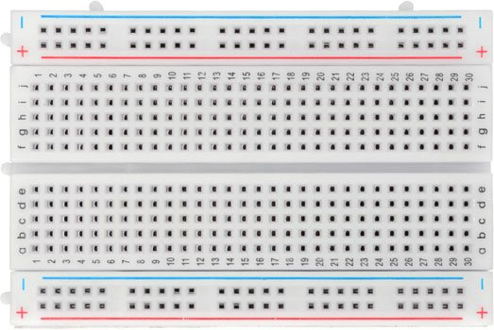

Figure2. A Bread Board

“A breadboard is a solderless device for temporary prototype with electronics and test circuit designs; Most electronic components in electronic circuits can be interconnected by inserting their leads or terminals into the holes and then making connections through wires where appropriate.” (Wiring, 2011) A breadboard is a generally used to structure and to test circuit. We don't have to bind wires and components to make a circuit while utilizing a bread board. It is simpler to mount components and reuse them. Since, components are not welded we can change our circuit plan anytime with no issue. It comprises of a variety of conductive metal clasps encased in a case made of white ABS plastic, where each clasp is protected with another clasps. There are many holes on the plastic box, organized in a specific style. Components can be inserted in the holes and complete a circuit.

1. **9 Volt Battery with Connective Wires:**

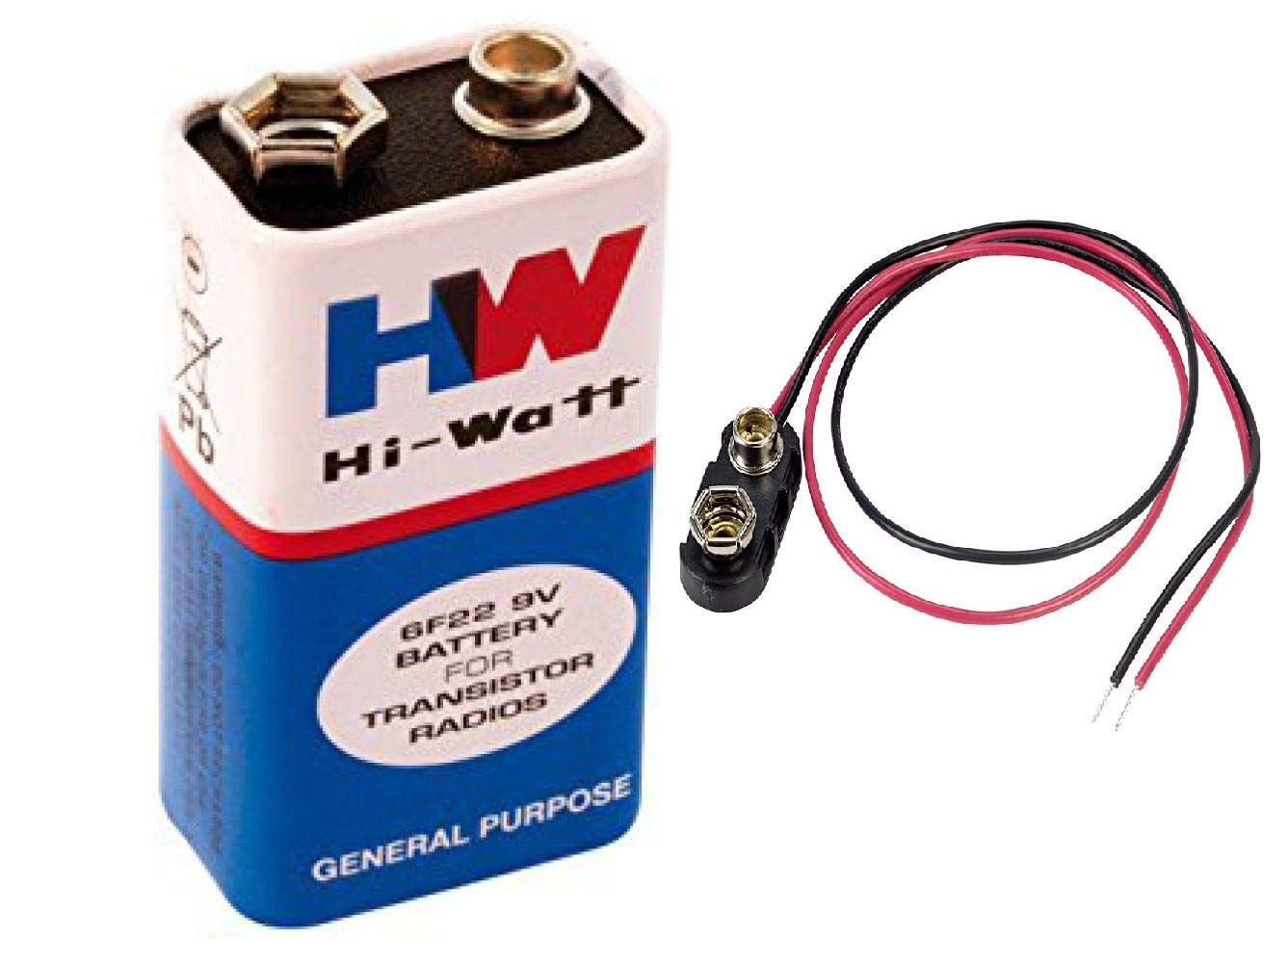

Figure2. : A 9V Battery with Connective Wires

“The **nine-volt battery** or **9-volt battery**, is a common size of battery that was introduced for the early [Transistor](https://en.wikipedia.org/wiki/Transistor_radio) radius. It has a rectangular prism shape with rounded edges and a polarized snap connector at the top.” (Wikipedia, 2020) . “The nine-volt battery format is commonly available in primary carbon-zinc and alkaline chemistry, in primary lithium iron disulfide, and in rechargeable form in nickel-cadmium, nickel-metal hydride and lithium-ion.” (Wikipedia, 2020) Inside the battery the elements are well arranged. There are two main part in a battery, which are anode and cathode. These positive and negative parts mainly work for voltage producing and power suppling.

The connectives wires use to connect the battery power output.

1. **BC547 NPN Transistor:**

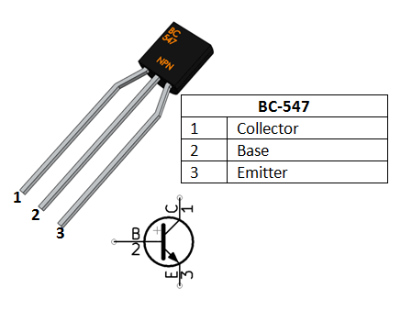

Figure2. : A BC547 NPN Transistor

A transistor is basically combination of a n-type and a p-type semiconductor. This works like an electrically controlled switch. There are a input, a output and a control line which is known as Emitter, Controller and Base. The BC547 is a NPN transistor meaning when power is applied to the base (control pin) it will flow from the collector to the emitter (BCRobotics, 2019). “The features of BC547 transistor are: Bi-Polar NPN Transistor; DC Current Gain (hFE) is 800 maximums; Continuous Collector current (IC) is 100mA; Emitter Base Voltage (VBE) is 6V; base Current(IB) is 5mA maximum; available in To-92 Package.” (Components101, 2020)

1. **LDR (Light Dependent Resistor):**

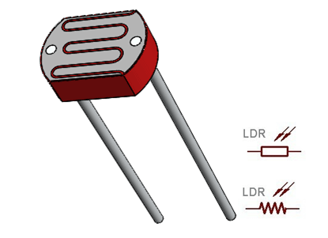

Figure2. A LDR with Symbol

A **Light Dependent Resistor** (LDR) is a device whose resistivity is a function of the incident electromagnetic radiation. Hence, they are light-sensitive devices (Electrical 4 U, 2020). LDR also known as Photo resistor.

LDR is basically made with semiconductor with resistor. The device is highly light sensitive. The resistance is depending on the light fall upon the LDR. If high amount of light is applied upon the LDR, the resistance will be very low and if the amount of light is low, then the resistance is high. Taking into account their low cost, simplicity of assembling, and convenience LDRs have been utilized in a wide range of uses. In our project LDR is the most important component.

1. **LED (Light Emitting Diode):**

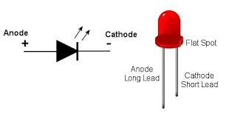

Figure2. 5 A LED with Symbol

“A light emitting diode(LED) is a diode that produces visible light when current flows through it while forwarded biased. Light-emitting diodes are not made from silicon or germanium but are made by using elements like gallium, phosphorus and arsenic. By varying the quantities of these elements, it is possible to produce light of different wavelengths that produces different color.” (Mehta & Mekta, 2015) Basically, LED produces light on current flow. Inside LED when electrons from negative side go to the positive sides recombination take place. While recombining electrons produce light energy and heat energy produces. That light energy can be visible by us. That’s how a LED produces light. In a LED light the longer lead is the positive side and the shorter lead is the negative side. We will use the LED to show that alarm is on.

1. **Resistors:**

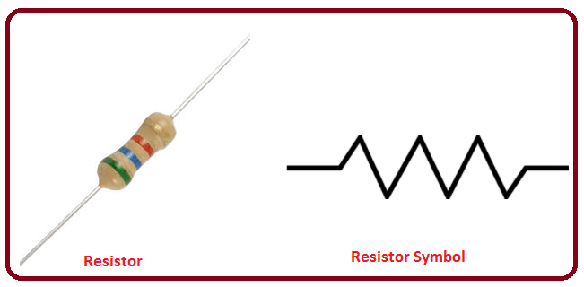

Figure2. : A resistor with Symbol

A resistor is a passive electrical component with the primary function to limit the flow of electric current. The main work of a resistor is to reduce current flow to any component. To minimize or increase the resistance of any connection or circuit resistors are used. In a resister, the amount of its resistance power is being fixed while manufacturing. Resistance of a resister is measured by Ohm(Ω). Resistor with high values are used to reduce current flow and resistor with low value resistance will have higher current flow. We will use a 39K Ω resistor in our project circuit.

1. **Buzzer:**

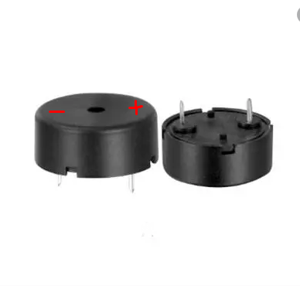

Figure2. : A Buzzer

A buzzer is generally an audio producing device. Buzzer is widely used in alarming by producing a constant wave sound. A buzzer can be easily used in a breadboard with it’s two connecting pins.

1. **Laser Light Pointer:**

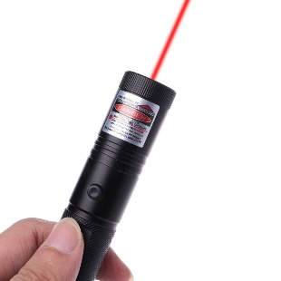

Figure2. : A Laser Light Pointer

A small device which have a laser light with a power supply and a switch is called laser pointer or laser light pointer. These devices are small which can be held in hand. We will use one laser pointer device in our project.

1. **Connecting Wires:**

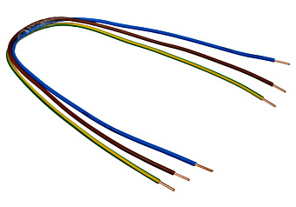

Figure2. : Connecting Wires

Connecting wires are simple current conduction wires with thin pins on the both sides to put the wire easily into the bread board’s hole.

1. **Cock sheets:**



Figure2. : Cock sheets

Cock sheet are needed for structural purpose of the projects outer design. We need three different size of cock sheets to make our project structure. It will be like a three side wall made by three cock sheets.

## Components Materials Expenditures:

|  |  |  |  |
| --- | --- | --- | --- |
| Materials | Quantity | Price | Amount |
| 1. LDR (5mm) | 1 pc | 10.00 | 10.00 |
| 1. Laser Pointer | 1 pc | 90.00 | 90.00 |
| 1. Bread Board | 1 pc | 70 | 70.00 |
| 1. Resistor(39kΩ) | 1 pc | 2.00 | 2.00 |
| 1. Transistor   BC547 | 1 pc | 2.50 | 2.50 |
| 1. Cock sheet | 3 pcs | 3*2 | 6.00 |
| 1. Male to Male Jumper Connecting Wires | 10 pcs | 10*3 | 30.00 |
| 1. LED (Red) | 1 pc | 2.00 | 2.00 |
| 1. Buzzer | 1 pc | 25.00 | 25.00 |
| 1. Rechargeable 9V battery with connecting wire | 1 pc | 245.00 | 245.00 |
| TOTAL | | | 482.5 TK |

**Table 2. 1: Components Materials Expenditures**

As the upper table shows the spending on the components for the project is around 483 Taka excluding a Super glue costing around 30 Taka.

# 

**Project development**

## Circuit Diagram:

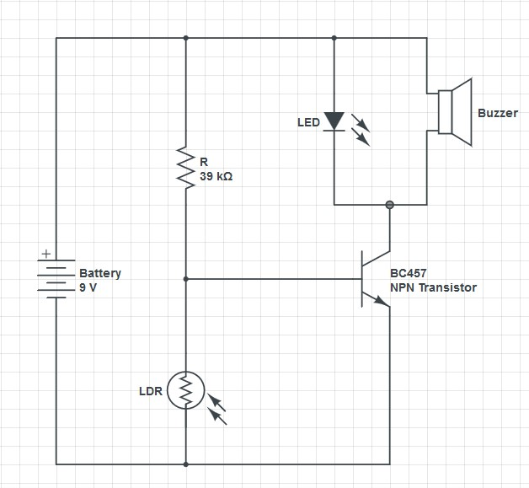

Figure 3. : Circuit Diagram

This circuit was drawn in circuitlab.com web site and simulated in circuit-diagram.org website. As it was drawn and tested in a AI platform we could primary say that the circuit structure will work for our project.

## Circuit Setup:

In Practical we used a breadboard to setup the whole circuit. The circuit was setup like this:

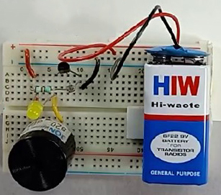

Figure 3. Circuit Setup

* First we took the BC547 transistor in the breadboard in a configuration where the Collector is the in the left side, Base is in the middle and Emitter is in the right side. We have to set it in the breadboard pins.
* Next we will connect the LDR across the base and emitter of the transistor.
* Then we connected the resistor across the Base of the transistor and an empty pin of the bread board.
* We connected the positive realm of the breadboard with the resistors one side which is in the empty pin of the bread board.
* We connected the LED across the positive realm and the Collector of the transistor. The anode of the LED is connected to the positive realm and the cathode of the LED is connected to the Collector of the BC547 transistor. We remembered that longer lead of the LED is anode.
* with the help of the connecting wires, the negative realm of the bread board was connected to the emitter of the transistor with the negative realm of the breadboard.
* The buzzer was connected with the positive realm and the collector of the transistor.

The positive terminal of the buzzer is connected to the anode of the LED and the negative terminal of the buzzer is connected to the collector of the transistor. So, in the circuit the LED and the Buzzer is connected in a parallel connection.

* With a board side tape, we stickled the 9V battery on the breadboard. Then we connected the anode part of the battery to the positive realm of the breadboard and the cathode part of the battery connected with the negative realm of the breadboard.
* Lastly we had to line up the Laser pointer with the LDR very perfectly so that the light of the pointer will fall upon directly to the LDR.

## Project Setup:

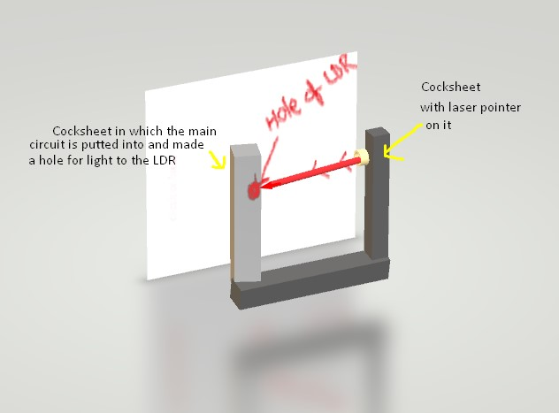

Figure 3. : Basic construction of the Project

* We mentioned three cock sheet earlier. These sheets we used to make the structure of the Intrusion Detection System Project.
* We make a cut in one cock sheet as same size of the breadboard. So that the breadboard can be easily goes into the cock sheet. We stick the board in position with super glue. Now, we make a hole upon the LDR so that light can be going to the LDR.
* In another cock sheet, we insert the laser light pointer very carefully. We should remember that the LDR and the laser pointer should be in same line up so that light of the laser pointer goes straight to the LDR surface.
* Now we use the third cock sheet as the base of the project. On this cock sheet, we arrange the other two cock sheet very carefully so that LDR and Laser pointer are in same line up and the laser light goes through the hole smoothly.

## Working Procedures of the Project:

* Our project mainly depends on the LDR (Light Depending Resistance). The characteristics of the LDR changes when the amount of light upon the LDR changes.
* The LDR and resistor R structures a potential divider arrange, which is the fundamental piece of our security system circuit.
* We have just talked about how transistor goes about as a switch, a similar guideline is utilized here. The voltage drop over the LDR is utilized to drive the transistor switch. When the voltage drop is above cut in voltage (0.6V), the transistor is turned ON.
* When the intensity of light is high, the LDR has low resistance and when the intensity of light is low, LDR has high resistance.
* In our project, we used a cock sheet containing one small hole which through the light from the laser will pass upon to the LDR. Light from any other sources cannot be fall upon the LDR. As light from the Laser pointer is falling upon the LDR continuously, the resistance of the LDR is also too low. That will result of low voltage drop across the LDR. So, the transistor remains switched off and Buzzer and LED are no use in the circuit.
* When something comes between the laser pointer and the LED, an obstruction is created. As the LDR don’t have any light upon it, the resistance of it will be very high and for that the voltage drop will rise up very high.
* When the voltage drop cross over the cut in voltage of the transistor, the BC 547 transistor will turn on. So the current will start to flow to ground via LED and Buzzer and turn on the LED and make beep sound of the buzzer.

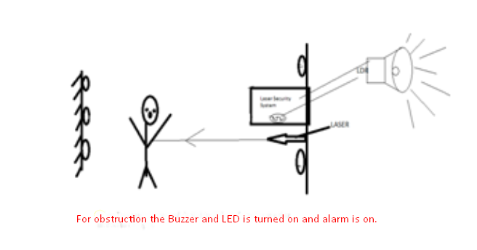

Figure 3. : Working Process of the Project

## Experiments:

At least three experiments were necessary to perform to test our project’s overall performances.

* We connected the 9V battery with the positive and negative realm of the board to test the functionality of the circuit.
* Before building the cock sheet structure, we set up the laser pointer straight upon to the LDR and examined the characteristics of the components.
* Then we made an obstruction in the pathway of laser light to LDR and observed the given output of the project circuit.
* We ran these three experiment again after building the whole circuit to see if the installation process did any damage to tour circuit system

# 

**Experiment Result & Discussion**

## Experiment results

We have done three basic experiment to test our project’s working capability.

* Our first experiment was about the main power supply test. We connected the battery with in the positive and negative realm of the breadboard. Then looked for any activities in the circuit.

When we connected the battery the whole circuit turns on and the power 9V will be supplied through the components. As LDR was not having a good amount of light on it, our buzzer started making sound and the LED was emitting light.

* The second experiment we tried was to check the characteristics of the LDR. We took the laser pointer in hand and pointed the laser light straight to the LDR.

Earlier, before putting the light on the LDR, buzzer and LED was turned on automatically. After sensing a large amount of light, the buzzer stopped buzzing and LED turned off.

* While putting the laser light on the LDR, we moved a hand to make obstruction between the laser pointer and LDR. When the light was being obstructed by the hand, Buzzer started beeping sound and the LED became on.

Table 4. : Experiment Results

|  |  |  |
| --- | --- | --- |
| Experiment | Buzzer | LED |
| Connect the Power Supply | ON | ON |
| Laser pointer is ON | OFF | OFF |
| Laser pointer is OFF | ON | ON |

## Discussion:

As the project was working perfectly after connecting the power suppling, we can say that our circuit drawing and implementation of the components were right. We connected all the components accurately so that the buzzer started to making the beeping sound.

Though the project circuit was working perfectly we wanted to be 100% sure of its efficiency. So, we pointed the laser light to the LDR. After having more amount of light on the LDR, the resistance of LDR becomes too low. For that the voltage drop of the LDR becomes low. So, the transistor cannot be switched on and the buzzer and LED cannot have any current supply across them. The buzzer and LED is turned off this time for that reason.

When we make an obstruction on the pathway of light, LDR has less amount of light on it. Resistance of the LDR increases and for that voltage drop increases. When voltage is high, the transistor is turned on. So the LED and Buzzer also become on.

If the obstruction moves out from the light’s pathway, the buzzer and LED become off. Again if the obstruction is created the buzzer and LED become on.

# 

**Conclusion**

## Conclusion

Before started doing something serious about electronics, it will be very helpful for us to practically make a circuit and implement in a project. In the subject “Fundamental of Electronics & Digital System Lab” we got the chance to work with a practical project. The project we worked on is “Intrusion Detection System”. We developed a laser security for this project.

Laser security alert will advise that somebody has intruded made sure about zone and simple. This task will give us successful secured territory to us. When this secured region will be penetrated, the alert will sound.

The report is started with the basic discussion of the components of the project. We briefly discussed about the LDR, LED, Transistor etc. We also talked about the components functionalities in the project.

Then we moved on to the circuit diagram part. We discussed about the diagram and how did we developed the circuit diagram. After discussion about circuit diagram, we talked about the project setup. We took all the components and implemented all the things as planned before. Three cock sheets containing the whole project system is made very simply. We did a discretional paragraph about the working procedure of our project. When light is putted directly on the surface of LDR, the resistance of it becomes low. If the LDR is in low resistance the, the voltage drop will be low. As the transistor won’t be on for that buzzer and LED won’t be on. Likely, when there is no light to LDR, the buzzer becomes on. This is the main working process of the project. We had to perform some experiments to check the working status of the project.

After finish these parts, we moved to the Experiment result and discussion chapter. Exact output of all the three experiments were explained elaborately and discuss about the expected result. Importance of the project, future scope and Achievement of the project is also discussed in the project report.

## Importance of the Project:

This intrusion detection system project is one of the major invention in security system. The use purpose of the project can be various.

* **Home Security:** As the project is very simple to build and low in cost, it can be implemented in home in more than one unit. To secure a door or to secure an ornament box or drawer we can use the project.
* **Thief Detection by the Project:** By implementing the project we can make an invisible likely barrier of which the thieve has no idea about. When a thief will cross the laser light, the buzzer and the LED light will be on and everyone will be alerted.
* **Laser lock:** By using the project we can also create a lock system where a valuable thing is locked by only the laser light. If something or someone wants to take the thing, he has to cross the laser light. If the implementer doesn’t switch off the circuit before crossing the laser, the laser will work as a light lock.

This project can be used in many other situations related to security purpose. We talked earlier that, as the technology is increasing day by day, the security threads are also increasing day by day. To minimize the threads, we have to maximize our security systems and have to think about higher thoughts about the security problem. This project will help us to maximize the security and be a revaluation in the small security system.

It can help forestall the odds of crime cases which are probably going to occur around night and even at day time. Finally, we can say that this is additionally material to schools, particularly in MCTI's premises, research centers, offices inside the border of the school.

## Achievement:

In this project, we expect to make simpler the circuits and its segments for family unit favorable situations. An extraordinary case of this is the advancements on PCs, the principal renditions were complicated and complex (Super Computer) and isn't compact for business use. As the innovation becomes move propelled, they have created things for increasingly advantageous and open ways like netbooks, workstations, tablet pc's and so forth.

We wanted to rebuilt a similar idea project yet with further preferences to be increasingly relevant in conventional family units. This means to give reasonableness such that littler houses and different purchasers can make the most of its advantages.

## Limitations:

As our project is without any switch, we cannot control it manually. Though it has advantage and limitation both. After connecting the power supply the circuit is switched on automatically. If there had been a switch in the circuit part, we could control the circuit power supply. But it would be also favorable to the fence breaker.

We could have use a program to send a message or email to the owner of the security system. As we didn’t use an Arduino in the project, we cannot do that.

## Future Scopes:

Laser security alert will advise that somebody has intruded made sure about zone and simple. This task will give us successful secured territory to us. When this secured region will be penetrated, the alert will sound.

We made the laser security in low spending plan. It had been ensuring in full security. Laser security frameworks are a cutting edge innovation that used to be a piece of home security as it were accessible to the rich.

It is physically switch subordinate sensors and a fundamental alarm unit. Laser has a few focal points when contrasted with other light sources like modest, less labor; productive, effectively accessible, plan is very simple.

The laser frameworks can be introduced at homes either by people with information on establishment or by specialists. By mechanical developments cost of the security frameworks has been sliced to a huge degree. In this way, making laser frameworks as one of reasonable security framework alternatives is protected and cost proficient. It has capacity to work constantly; it isn't just human yet additionally a little creature or some other mobile articles. Its disturbing Sound doesn't stop until someone stops it.



Figure 5. : Project Using in Home Security

Further the project can be also extended in many big security projects. Various banks are using intrusion detection system. For securing the volt of the bank extended version of our project can be used.

Mirror Laser Security Intrusion Detention System also can be made by our projects. In future for making these highly security system, this project will make a very good example.

# **References**

BCRobotics. (2019). *NPN Transistor – BC547*. Retrieved June 12, 2020, from BCRobotics Web site: https://www.bc-robotics.com/shop/npn-bc547-transistor/

Components101. (2020). *BC547 Transistor*. Retrieved June 2020, from Components101 Web site: https://components101.com/bc547-transistor-pinout-datasheet

Electrical 4 U. (2020). *Light Dependent Resistor (LDR) or Photoresistor (What is it?)*. Retrieved June 12, 2020, from Electrical 4 U Web site: https://www.electrical4u.com/light-dependent-resistor-ldr-working-principle-of-ldr/

Mehta, V., & Mekta, R. (2015). LED. In V. Mehta, & R. Mekta, *Principles of Electronics* (pp. 126-129). New Delhi: S. Chand & Company LTD.

Wikipedia. (2020, May 31). *Nine-volt battery*. Retrieved June 12, 2020, from Wikipedia Web site: https://en.wikipedia.org/wiki/Nine-volt_battery

Wiring. (2011). *Breadboard*. Retrieved June 12, 2020, from Wiring Web site: http://wiring.org.co/learning/tutorials/breadboard/